CARDLESS ATM BANKING WITH OTP TECHNIQUE

S.GNANASEKARAN,
AP/ECE,
Paavai engineering college,
Namakkal,
gnanamks2005@gmail.com

Devi.M,
Student,
Paavai engineering college,
Namakkal,
Deviece271198@gmail.com
Gowsalya.C,
Student,
Paavai engineering college,
Namakkal,
kowsi311298@gmail.com,

Jothi.C,
Student,
Paavai engineering college,
Namakkal ,
jothichandhiran@gmail.com

Abstract— The growing direct or spoofing fraudulent attacks of thieves has motivated us to focus our prime concern on the security over money transaction. The need of money can only be satisfied when you are carrying money with you that also increases the risk of getting robed. Bank is a safest place to keep money. Bank provides Automated teller machine (ATM) which can provide money anywhere you want. ATM is an easy way to get money, you just need to insert card and password and you just got the money. But what if someone steals your card and somehow he/she will know your password, it will grant him/her full access to your money. That raises the question on present security and demands something new in the system that can provide second level of security. The self-governing ATM host has a right to use any bank and there is no security layer implemented in the ATM card except pin number. We need to monitor the location of the ATM usage, time taken for the user to access the ATM machine, sequence of events processed by the user and expected amount of withdrawal by the user. All these four factors are verified for the authentication purpose of the user along with password. The method proposed in this project focuses on how the money transaction in an ATM machine will be secured by providing personal identification by analyzing biometrics like fingerprints and iris patterns which are known for their steadiness and diversity. In this system we are entering the account number, after which OTP will be received in registered mobile number. By using OTP we can access our ATM account through an acknowledgement.

Keywords—security,ATMmachine,self governing,money,password

I. Introduction
In most of the offices and banks lockers are used to secure valuable documents or any valuable thing so Locker security is becoming an important issue in recent days. Nowadays there is demand for more efficient security systems to avoid access of unauthorized persons. In sent system a unique password is set to open locker, which is only known to authorized person. The user uses this password again and again so somebody can hack that password and also if password leaks then it affects security of system. The most of locker systems are based on only mechanical key operations; if key is misplaced or stolen then again it is difficult to maintain security of that locker. There are some security systems based on GSM, Fingerprint and RFID exists. In RFID technology is used to read the customer information whereas GSM technology is used to send the password to the authorized person’s mobile phone via SMS. The system in is similar to as it is based on RFID and GSM but only difference is after code conformation of RFID tag password request sent to authorized person, if the person send the password to the microcontroller, which will verify the passwords entered by the key board and received from authenticated mobile phone. If these two passwords are matched the locker will be opened otherwise it will be remaining in locked position. The proposed system is developed to overcome the limitations of above methods. When an authorized person insert locker key that time MC generates random password and send it to user mobile using GSM module. When user enters a password via key pad, the door can be open. If the entered password is correct it displays that “Code is Correct- Access allowed.” and if the three times entered password is wrong it gives beep signal and displays “Code is incorrect- Access is denied.”
Proposed system
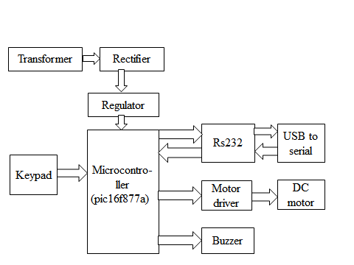
Figure: Proposed system block diagram

Power supply unit
The present chapter introduces the operation of power supply circuits built using filters, rectifiers, and then voltage regulators Starting with an AC voltage a steady DC voltage is obtained by rectifying the AC voltage then filtering to a DC level, and finally, regulating to obtain a desired fixed DC voltage. The regulation is usually obtained from an IC voltage regulator unit, which takes a DC voltage and provides a somewhat lower DC voltage, which remains the same even if the input DC voltage varies, or the output load connected to the DC voltage changes.
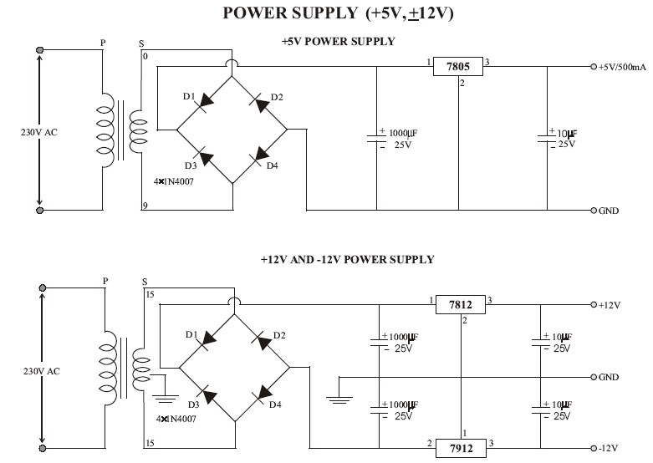
DC MOTOR
Almost every mechanical movement that we see around us is accomplished by an electric motor. Electric machines are a means of converting energy. Motors take electrical energy and produce mechanical energy. Electric motors are used to power hundreds of devices we use in everyday life. Motors come in various sizes. Huge motors that can take loads of 1000’s of Horsepower are typically used in the industry. Some examples of large motor applications include elevators, electric trains, hoists, and heavy metal rolling mills. Examples of small motor applications include motors used in automobiles, robots, hand power tools and food blenders. Micro-machines are electric machines with parts the size of red blood cells, and find many applications in medicine.

Principle of operation
Consider a coil in a magnetic field of flux density . When the two ends of the coil are connected across a DC voltage source, current I flow through it. A force is exerted on the coil as a result of the interaction of magnetic field and electric current. The force on the two sides of the coil is such that the coil starts to move in the direction of force.

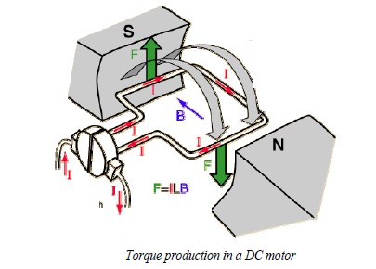

KEY PAD (4X1 MATRIX)
This note describes an method of interfacing a matrix keyboard to EZ328 using minimum number of I/O ports. We use a 4x1 matrix keypad as an example. It requires only five I/O ports. (In general, it takes n+1 ports to interface a nxn matrix keyboard). It is a low cost solution. No TTL logic ICs are used. The components mainly used in the interfacing circuitry include only diodes and resistors which can greatly reduce the system cost and size of the product
USB to SERIAL PORT
When USB technology began to take hold, engineers were scrambling to learn how to use the new interface in their designs. With the legacy serial and parallel ports on the verge of extinction, any design that required them would soon be left without a mate. Citron foresaw the panic and designed UC00A, an easy-to-use USB (Universal Serial Bus) to UART (Universal Asynchronous Receiver/Transmitter) converter. This product assures the lifespan of any equipment that interfaces with computer us ing serial port would be extended without the need for in-depth knowledge of USB protocol. Upgrading RS232 legacy peripherals to USB is really simple with UC00A
. 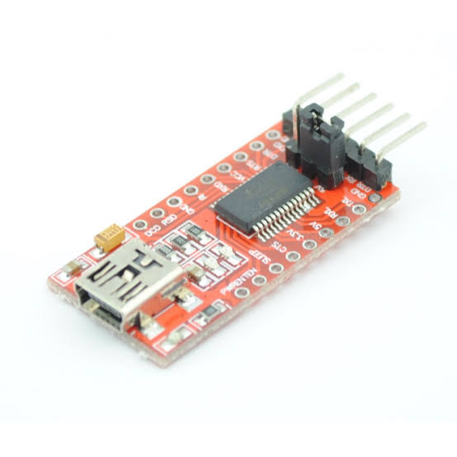
.
USB to SERIAL PORT

Architectural overview
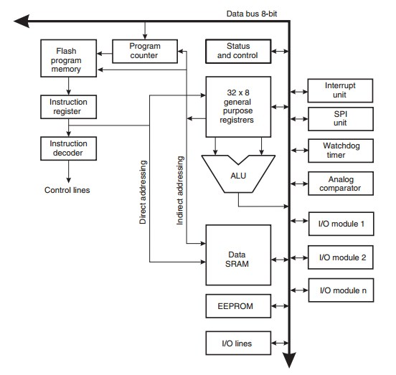

Architectural overview
In order to maximize performance and parallelism, the AVR uses a Hardware architecture – with separate memories and buses for program and data. Instructions in the program memory are executed with a single level pipelining. While one instruction is being executed, the next instruction is pre-fetched from the program memory. This concept enables instructions to be executed in every clock cycle. The program memory is In-System Reprogrammable Flash memory.
All interrupts have a separate Interrupt Vector in the Interrupt Vector table. The lower the Interrupt Vector address, the higher the priority. The I/O memory space contains 64 addresses for CPU peripheral functions as Control Registers, SPI, and other I/O functions. The I/O Memory can be accessed directly, or as the Data Space locations following those of the Register File,
0x20 - 0x5F. In addition, the ATmega48/88/328 has Extended I/O space from 0x60 - 0xFF in SRAM where only the ST/STS/STD and LD/LDS/LDD instructions can be used.
Importance of Java to the Internet
Java has had a profound effect on the Internet. This is because; java expands the Universe of objects that can move about freely in Cyberspace. In a network, two categories of objects are transmitted between the server and the personal computer. They are passive information and Dynamic active programs. in the areas of Security and probability. But Java addresses these concerns and by doing so, has opened the door to an exciting new form of program called the Applet.
Applications and applets.
An application is a program that runs on our Computer under the operating system of that computer. It is more or less like one creating using C or C++ .Java’s ability to create Applets makes it important. An Applet I san application, designed to be transmitted over the Internet and executed by a Java-compatible web browser. An applet I actually a tiny Java program, dynamically downloaded across the network, just like an image. But the difference is, it is an intelligent program, not just a media file. It can be react to the user input and dynamically change.
Java Architecture
Java architecture provides a portable, robust, high performing environment for development. Java provides portability by compiling the byte codes for the Java Virtual Machine, which is then interpreted on each platform by the run-time environment. Java is a dynamic system, able to load code when needed from a machine in the same room or across the planet

Our system
In most of the offices and banks lockers are used to secure valuable documents or any valuable thing so Locker security is becoming an important issue in recent days. Nowadays there is demand for more efficient security systems to avoid access of unauthorized persons. In sent system a unique password is set to open locker, which is only known to authorized person. The user uses this password again and again so somebody can hack that password and also if password leaks then it affects security of system. The most of locker systems are based on only mechanical key operations; if key is misplaced or stolen then again it is difficult to maintain security of that locker. If these two passwords are matched the locker will be opened otherwise it will be remaining in locked position. The proposed system is developed to overcome the limitations of above methods. When an authorized person insert locker key that time MC generates random password and send it to user mobile using GSM module. When user enters a password via key
RESULT
This project demonstrates how an automation of prevention from robbery (or) thief can be implemented using NETBEANS IDE Technology with Code Vision AVR can be implemented in ATM Machines center. By implementing this project, we can catch thief and robberie’s in ATM itself and also we can save our precious time.

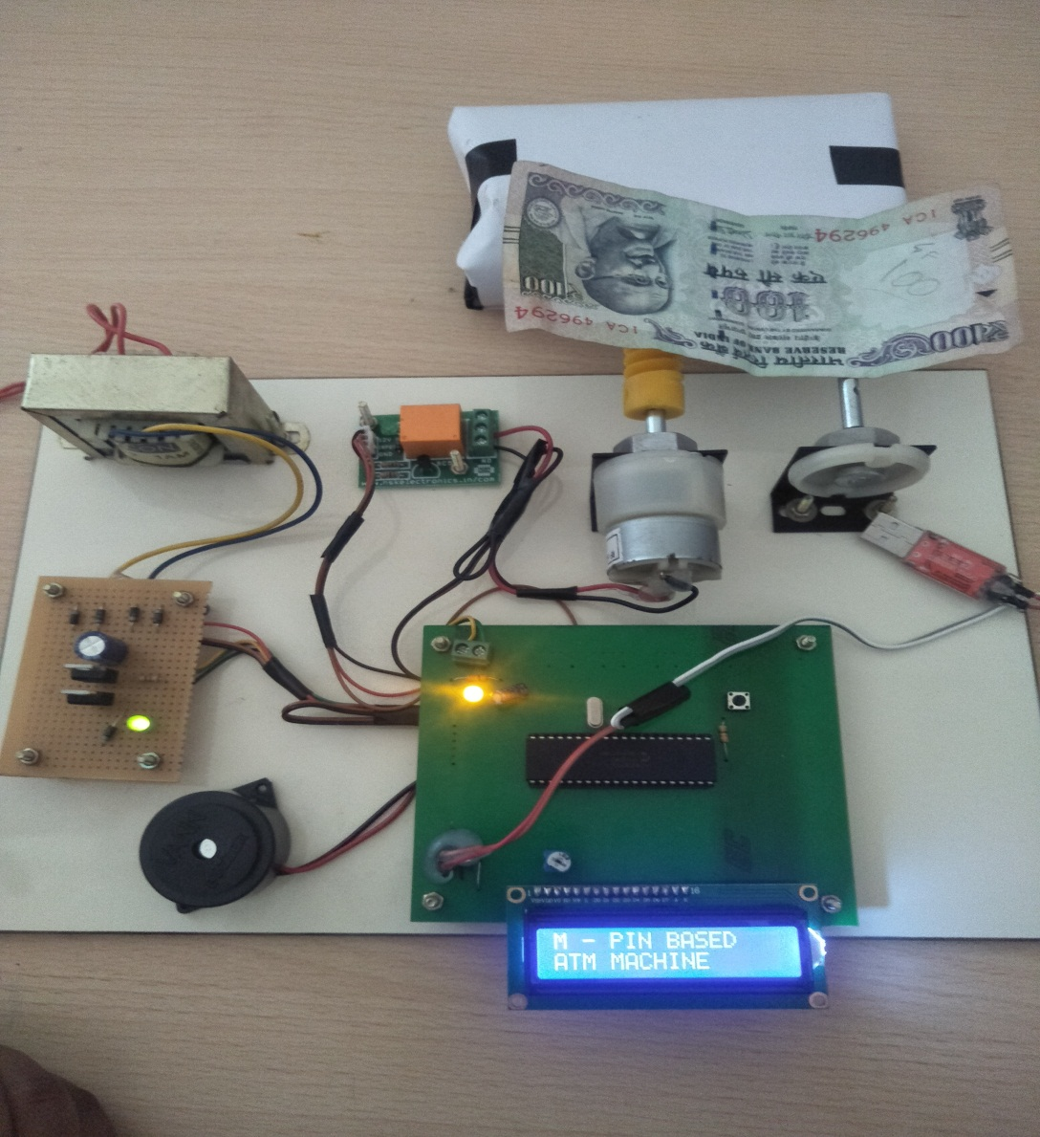

HARDWARE KIT

REFERENCES

- L.Coetzee and E.C Botha,”Fingerprint recognition in low quality images”,patten recognition,vol.26(10),1993
- Leow,H.B(1999) New distribution channels in banking services.Banker’s journal Malaysia
- A.M.Bazen and S.H.Gerez,”Achievement and challenges in finger print recognition”,in biometric solutions for authentication I an e-world,2002
- Siddque,M.I&Rehman,s.(2011) Impact of electronic crime in indan banking sector –An overview int.International Journal of Business &Information Technology vol.no.2 september 2011
- kannan,p(2013) and Ms.p.Meenaksi vidya “Design and implementation of security based ATM theft monitoring system”.

